***2Clap***

***Team Directory Dataset: <replace this text with dataset name>***

|  |  |  |  |
| --- | --- | --- | --- |
| Name | Phone | Email | Academic Status  Fr | So | Jr | Sr |
| David Luo | (847) 363-4220 | [Luo354@purdue.edu](mailto:Luo354@purdue.edu) | Sr |
| Kyle Choi | (646) 647-4407 | [Choi687@purdue.edu](mailto:Choi687@purdue.edu) | So |
| Lauren Behnke | (219) 741-2791 | [Behnkel@purdue.edu](mailto:Behnkel@purdue.edu) | So |
|  |  |  |  |
|  |  |  |  |

***Meeting Schedule***

*Starting 3/9/2022, our team will meet at a frequency of twice per week until the completion of the project. Edit the table below accordingly.*

|  |  |  |
| --- | --- | --- |
| Meeting Dates | Meeting Times | Method of Communication |
| Thursday | 5:00 – 6:00PM | Text/Chat/Discussion Meeting |
| Wednesdays | 9:30 – 11:30AM | Face-to-Face Meeting |

***Team Rules and Expectations (Items 1 – 9 are required; do not remove or edit)***

1. Our project’s success depends on the contributions, commitment and best efforts of all team members; therefore, everyone must actively participate to achieve their respective interdisciplinary activities.
2. We must all come to a consensus when making decisions about the project at hand. As a team we are to:
   1. Look at each situation individually
   2. Obtain input from all team members
   3. Communicate our understanding of all information
   4. Make the best decision based on the information presented

In the event that we cannot all agree or come to a consensus, then we will go by the majority rule vote.

1. Each individual is responsible for communicating with the team if any issues arise that may interfere with the completion of their assigned tasks or there is a difficulty attending any one of the meetings.
2. Each team members must maintain their contact information current. If there are any changes, the team must be informed of those changes as soon as possible.
3. All team members are responsible to follow-up and provide updates on the assigned task.
4. All project team members confront issues directly and promptly.
5. The Team Leader will document each team member’s contributions to the project and submit all weekly summaries and final project report to Professor.
6. We are all responsible for holding each other accountable. If any team member does not adhere to the rules and expectations set forth, individuals have every right to contact the Professor to state their concerns or discuss those openly with the team.
7. Any changes to the project baseline must be communicated with the team first and everyone must come to an agreement of the changes

***Code of Ethics (Items 1 -5 are required; do not remove or edit)***

1. We are to treat each other with respect and dignity.
2. We will be open to new ideas and information for the benefit of the project objective.
3. We will give each other an equal opportunity to voice opinions and contributions.
4. We will be honest and truthful in the information we present.
5. We will adhere to commitment to complete each assigned task set forth as part of the group project.

***Rotating Team Leader***

**Each team member MUST serve as the Team Leader at least once during the hackathon.** Update the table below by indicating who will serve as the team leader for each week. The team leader will be responsible for submitting team related deadlines, but the entire team must contribute to the assignment regardless of who is the leader for the week.

|  |  |  |  |
| --- | --- | --- | --- |
| Week | Team Leader | Dates of Leadership | Group Assignments Due This Week |
| Week 9 | N/A | March 7 – 13, 2022 | 1-minute Elevator Pitch |
| Week 10 | Spring Break |  |  |
| Week 11 | David Luo | March 21 – 27, 2022 | Team Registration + Team Agreement |
| Week 12 | Kyle Choi | March 28 – April 3, 2022 | Web page prototype |
| Week 13 | Lauren Behnke | April 4 – 10, 2022 | 5-minute Group Video |
| Week 14 | David Luo | April 11 – 17, 2022 | Team Presentations |
| Week 15 | Kyle Choi | April 18 - April 24, 2022 |
| Week 16 | Lauren Behnke | April 25 – May 1, 2022 | Hackathon Report + Final updates to project web page |

***Type each team member’s name in the list below.***

***Signatures Date***

1. David Luo3/09/2022
2. Lauren Behnke 3/09/2022
3. Kyle Choi 3/09/2022

***The Team Group Photo***

**Take a group photo (in lab) and include a copy in the space below. Make sure to add a figure caption that includes the names of group members, from left to right.**

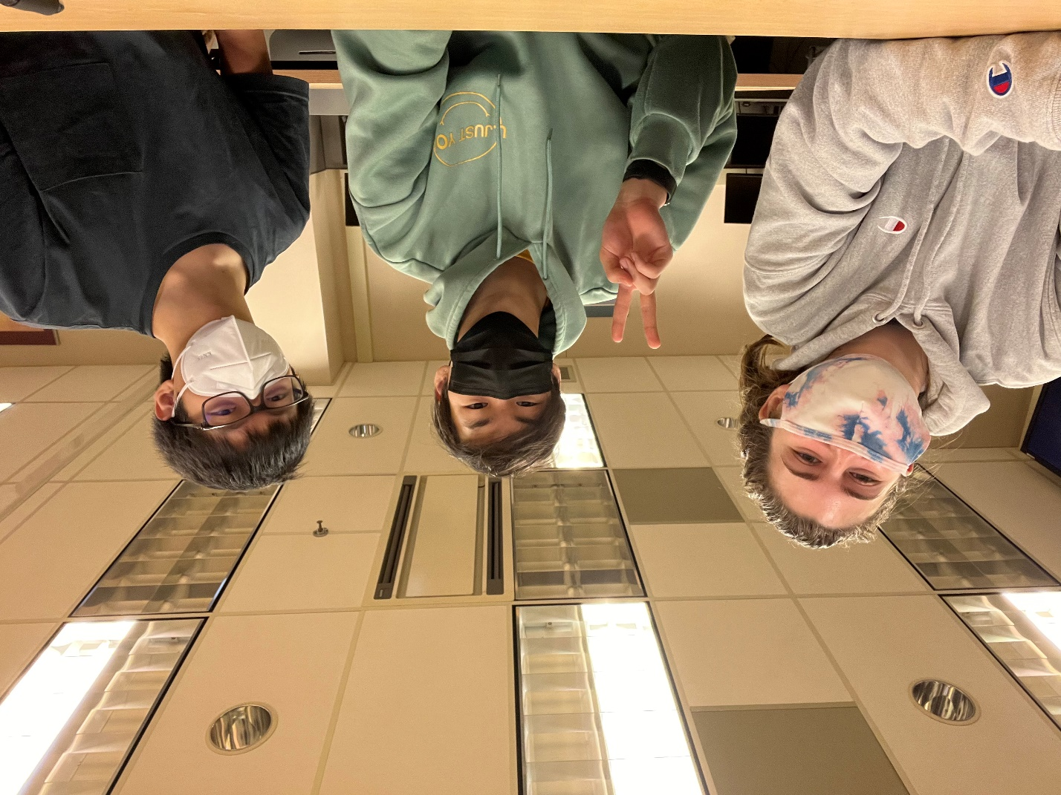

Figure Caption: Lauran Behnke, Kyle Choi, David Luo

* Save this document as **2Clap_CGT270Spring2022_Hackathon.pdf**
* Replace TeamName with the team’s name.
* Every member of the team must submit a copy of the same team agreement.
* If the agreement is not the same for each team member, the agreement is void.